Program Information

Lesson:

Employability Skills: Communication Skills

Training:

Fiber Optic

Time frame:

60 minutes

Instruction Section

Learning Objectives:

Enhance verbal communication and active listening techniques with customers and coworkers.

Develop active listening techniques for better information gathering and clarification.

Improve comprehension and conveying of written information related to cabling projects.

Apply observation skills in customer and coworker interactions.

Assessment Tools/Methods:

Provide specific, constructive feedback based on the observations, highlighting strengths and areas for improvement.

Encourage participants to reflect on their performance and discuss their learning outcomes.

Learner Prior Knowledge:

Basic Understanding of Fiber Optic Technician Tasks: Familiarity with the day-to-day responsibilities of a fiber optic technician, such as installation, testing, troubleshooting, and customer interaction.

Terminology Related to Fiber Optics: Knowledge of common terms like "OTDR testing," "single-mode," "multi-mode," "connectors," and "termination."

Basic Technical Knowledge: A foundational understanding of fiber optic components and installation methods. Ability to read and interpret simple work orders and diagrams.

Customer Interaction Experience: While not mandatory, previous experience or examples of customer interaction in technical roles will help participants relate to the scenarios.

Instructional Activities:

Begin by asking participants, “Why is communication important in a technical role like fiber optics?”

Lead a brief discussion, asking if anyone has faced challenges in communicating with coworkers or customers.

Activity 1: Verbal Communication

Distribute scenario cards from the first section of the Scenario Handout (Verbal Communication) where participants must explain technical issues or progress updates to a customer or coworker.

In pairs, each participant takes turns acting as the technician, and the other participant plays the customer or coworker as they work through the scenario.

Focus on clarity, tone, and using language the customer or coworker can understand.

After the role-play, ask participants to share their experiences.

Ask participants to discuss what they did to ensure their message was clear and how did they adapt their language based on the scenario.

Activity 2: Active Listening

Partner participants and give them scenarios from the Scenario Handout (Active Listening) where one must listen and understand the message.

Explain how active listening can prevent misunderstandings and enhance collaboration, especially for those beginning in the fiber optic field.

Complete a listening exercise where one participant describes a problem while the other listens and summarizes the key points; then switch roles and repeat.

Discuss the importance of paraphrasing and asking clarifying questions.

After the role-play, ask participants to discuss signs that indicated the other person was actively listening.

How did it feel to be listened to without interruption?

Conclude the section by reviewing key points:

Maintaining eye contact and nodding.

Paraphrasing what was said to confirm understanding.

Avoid interrupting.

Use open-ended questions to encourage further discussion.

Ask for clarification if the message is not clear.

After the role-play, ask participants to discuss signs that indicated the other person was actively listening.

How did it feel to be listened to without interruption?

Activity 3: Written Communication Skills

Provide participants with the Sample Work Order .

Ask them to identify key details (e.g., type of cable, testing requirements, installation notes) on the work order.

Instruct participants to write a brief summary of their next steps to convey to a coworker.

Share summaries and evaluate clarity and completeness.

Hold a group discussion about how clear notes help technicians on the job.

Activity 4: Observation Skills and Wrap-up Activity

Show participants a diagram of a fiber optic installation site from the Image Handout for one minute.

Remove the diagram and ask participants to write down what they remember.

Compare observations and discuss, “Why is careful observation critical during installation and troubleshooting?”

Once the activity is complete, discuss how the activity can help prepare the participants for similar situations in the field.

Recap the key points of effective verbal communication, active listening, written communication, and observation and highlight how these skills contribute to professional development and workplace efficiency.

Fiber optic technicians often need to document their work accurately, whether it’s through work orders, test reports, or incident logs.

Clear, precise written communication is crucial to ensuring that all team members, including customers, understand the work completed and any follow-up required.

Discuss the role of communication in resolving misunderstandings or conflicts.

Encourage participants to approach conflicts calmly, keeping the focus on problem-solving.

Resources:

Whiteboard and markers

Scenario Handout

Sample Work Order Handout

Image Handout

Note: AI, specifically ChatGPT 3.5, was used to generate scenarios for this contextualized lesson plan.

Reflection Section

How can effective verbal communication and active listening improve interactions between fiber optic technicians and both customers and coworkers? In what ways does clear documentation and conflict resolution contribute to the success of fiber optic installations and overall teamwork?

Scenario Handout
Scenario Cards for Verbal Communication
- Scenario 1: Explaining a Delay in Installation
You are a fiber optic technician, and you're explaining to a customer why the fiber optic installation at their business is taking longer than expected.
  - The reason for the delay is that the fiber splice in the building is taking longer than anticipated.
  - You need to explain the situation clearly without causing frustration.
- Scenario 2: Discussing Fiber Testing Results
You’re talking to a coworker about the results of an OTDR test performed on a recently installed fiber link. The test showed an issue with the splice loss.
  - Explain the issue to your coworker, offering suggestions for troubleshooting.
- Scenario 3: Communicating Safety Concerns on a Job Site
You are on a job site and notice a coworker is not following proper safety protocols while working with fiber optic cables.
  - Politely inform them of the safety guidelines and why they are important.
- Scenario 4: Giving a Customer an Update on Their Service
A customer calls and asks about the status of their internet installation.
  - Explain the current stage of the installation and when they can expect completion.

Scenario Cards for Active Listening
- Scenario 1: Customer Describes a Problem with Their Internet Connection
A customer calls and describes their internet not working intermittently. They mention that they've tried rebooting their router but still experience issues.
  - Listen carefully, ask follow-up questions to gather more details, and paraphrase what they say to confirm your understanding.
- Scenario 2: Coworker Explains an Issue with Fiber Optic Cable Installation
Your coworker explains that the fiber optic cable they installed appears to have some signal loss, but they are unsure of the cause.
  - Actively listen, ask questions to help narrow down the issue, and summarize their concerns to ensure you understand the problem.
- Scenario 3: Customer Expresses Frustration with Delay
A customer is upset because their internet installation is delayed due to an unforeseen issue.
  - Listen without interrupting, acknowledge their frustration, and summarize their feelings to show empathy before offering a solution.
- Scenario 4: Supervisor Explains Job Expectations for a New Project
Your supervisor outlines the scope of work for a new fiber optic installation project.
  - Listen attentively, take notes, and paraphrase key points to confirm your understanding.

Sample Work Order Handout
Sample Work Order for Fiber Optic Technician

Work Order #: 10234
Date Issued: 10/01/25
Technician(s) Assigned: Tech 1, Tech 2, Tech 3
Job Site/Customer: ABC University
Job Type: Installation

Job Description:
- Install 12-strand single-mode fiber optic cable for building network upgrade.
- Terminate fiber at each end using LC connectors.
- Conduct OTDR testing to ensure proper signal integrity.
- Document the results and prepare a report for the customer.

Site Requirements:
- Power Supply: Ensure 110V power is available at the work site.
- Equipment Needs:
  - Fiber optic splicing kit
  - OTDR (Optical Time Domain Reflectometer)
  - Cable jacket stripper
  - LC connectors
  - Fiber cleaver
- Safety Equipment:
  - Safety glasses
  - Gloves
  - High-visibility vest

Fiber Cable Details:
- Cable Type: Single-mode, 12-strand
- Cable Manufacturer: [Insert Manufacturer Name]
- Cable Length: 300 meters
- Jacket Type: Plenum-rated
- Fiber Count: 12 fibers
- Fiber Mode: Single-mode

Route/Path Details:
- Installation Path:
  - Start at the main entry of the building (Room 101)
  - Run cable through the main hallway to Room 205
  - Ensure cable is installed in cable trays and properly secured
- Cable Path Map: (Include a simple diagram or mention if one is attached)

Testing Requirements:
- OTDR Test:
  - Test at both ends after installation to check for signal loss.
  - Loss threshold: Max loss < 0.5 dB per splice.
- Connector Test:
  - Verify all LC connectors meet industry standards for insertion loss (<0.3 dB).
Completion Notes:
- Expected Completion Date:
- Customer Instructions: Ensure to notify customer upon completion of testing and before sealing cable pathways.
- Special Instructions: Ensure fiber splices are protected with proper closures.

Sign-Off:
- Technician Signature: ________________________
- Supervisor Approval: ________________________

Image Handout
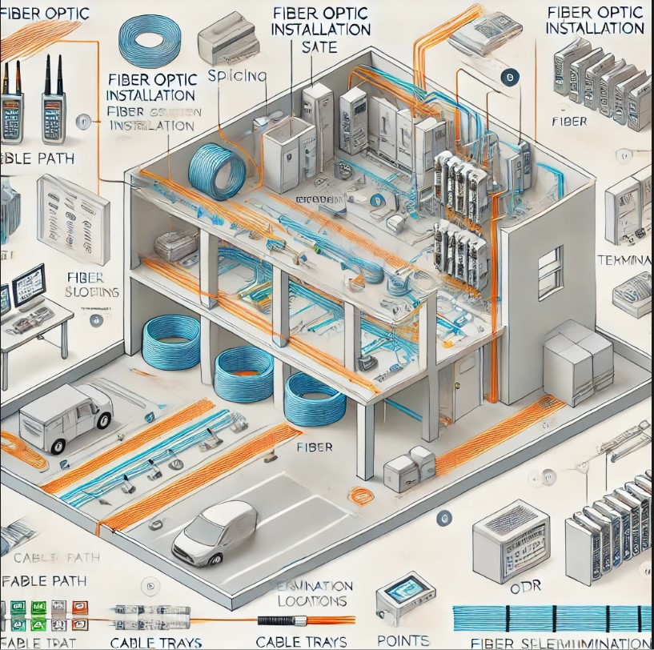
Note: OpenAI’s DALL·E images are provided to users for personal, educational, and commercial use under the terms of service, as long as they do not violate any applicable laws.

